Preparation of isotropic pitch precursor using ethylene bottom oil and polyvinyl chloride mixtures

(¹Interdisciplinary Graduate School of Engineering Science, Kyushu University, ²Institute of Materials Chemistry and Engineering, Kyushu University) ○Jinchang Liu¹, Koji Nakabayashi², Jin Miyawaki^{1,2}, Seong-Ho Yoon^{1,2}

In this study, we used polyvinyl chloride (PVC) as a source for halogen source for a preparation of ethylene bottom oil (EO) based isotropic pitch by chlorination-dehydrochlorination because PVC can be decomposed into together with an evolution of Cl radicals and remaining polyyne type radical molecules at over 250ºC. We closely examined the preheat treatment effect of EO on the reaction with PVC to prepare isotropic pitch precursor for carbon fiber with excellent tensile strength.

1. Introduction
Ethylene bottom oil (EO) has been used as a potential raw material for isotropic pitch based carbon fiber (CF). We have developed isotropic pitch based CF with an excellent tensile strength for car-body application using EO as a starting material. Specially developed spinnable isotropic pitch through the novel halogenation-dehydrohalogenation of EO could successfully afford CF with better tensile strength compared to CF from usual isotropic pitch^{1,2)}. However, there remains much room for improving the preparation method and the pitch properties for better spinnability, stabilization property and mechanical property.
In this study, we used polyvinyl chloride (PVC) as a source for halogen source for the preparation of EO based isotropic pitch for chlorination-dehydrochlorination because PVC can be decomposed into together with an evolution of Cl radicals and remaining polyyne type radical molecules at over 250ºC. We closely examined the preheat treatment effect of EO on the reaction with PVC to prepare isotropic pitch precursor for CF with excellent tensile strength.
2. Experimental
EO was preheat treated with vacuum distillation at various temperatures of 190–270ºC for 1 h, and then, reacted with 0–20 wt% of PVC at 370ºC for 1 h. EO270PVC5 depicts an isotropic pitch prepared with preheat treatment at 270ºC and reacted with 5 wt% PVC. Softening point (Ts) of isotropic spinnable pitches was finally controlled to 260ºC by thin layer evaporation (TLE) through removing light components in basic pitch. The obtained spinnable pitches were spun into pitch fiber by melt spinning at 310ºC. The raw materials and pitches were analyzed by thermogravimetry (TG), time-of-fly mass spectrometry (TOF-MS) and nuclear magnetic resonance (NMR).
3. Results and Discussion
From TG analysis, PVC decomposition can be divided into 3 stages (Fig. 1). In the first stage, PVC started to degrade from 250ºC to 290ºC and weight loss was about 56% which was close to theoretical value (58.4%) of HCl content in PVC. The second stage was from 300ºC to 340ºC. This stage might be owned to condensation of polyenes, which began to form pitch state by back-biting reaction. The third stage was over 370ºC and mainly was ascribed to aromatization of smaller molecular by reason of Diels-Alder reaction³⁾. The second and third stages are important for pitch preparation. In the second stage, the nucleated Cl radicals initiated the chlorination with methylene hydrogen and continuously dehydrochlorinate together with methylene cross-linking, increasing molecular weight of resulted pitch.
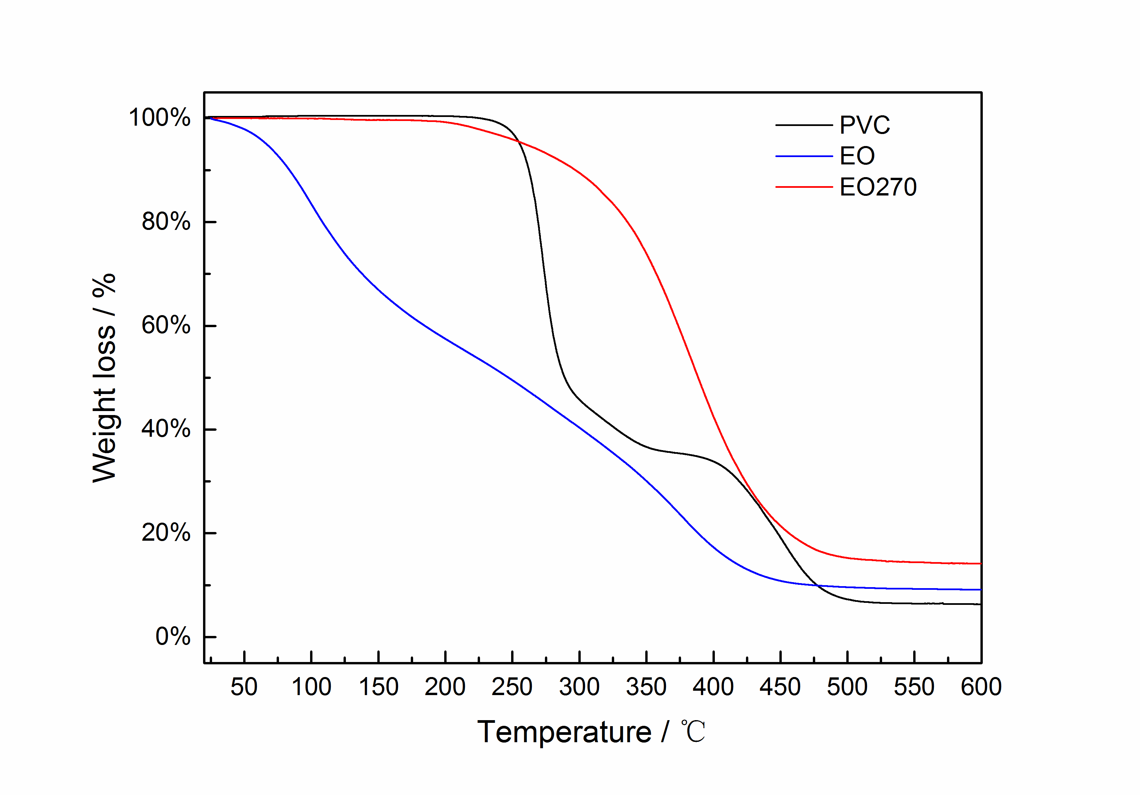
Table 1 shows the comparative results of the pitch preparation with EO270 and PVC mixtures. The addition of PVC could increase the pitch yield and softening point slightly with increasing the molecular weight of the resulted pitch. However, total yield of pitch after TLE were very similar with 15–20%. In the presentation, we will show the results of the pitch spinnability.
Table1 Yield (based on EO) and Ts of basic and spinnable pitches.
Pitch | Yield /% | Ts /ºC |  | Yield /% | Ts /ºC
EO | 77.68 | < RT | TLE | 15.10 | 260
EO270 | 32.23 | 130 |  | 19.84 | 260
EO270PVC5 | 35.48 | 110 |  | 18.07 | 260
EO270PVC20 | 39.83 | 130 |  | 16.49 | 260

Fig.1 TG curves of raw materials.

References
1) B.-J. Kim, H. Kil, N. Watanabe, et al., Curr. Org. Chem., 17, 1463–1468 (2013).
2) B.-J. Kim, Y. Eom, O. Kato, J. Miyawaki, B.C. Kim, I. Mochida and S.-H. Yoon, Carbon, 77, 747–755 (2014).
3) I. Mochida, H. Toshima, Y. Korai and T. Matsumoto, J. Mater. Sci., 25, 76–82 (1990).

